
BS-Software Engineering
Software Development & Construction
Report
Instructor: Dr Zunnurain Hussain Teaching Assistant: Umair Makhdoom
Project Title: Cloud Based E – Commerce Platform



Group Members:
- Muhammad Numan Tahir – BSSE23069
- Muhammad Zubair Akhter – BSSE23079

Introduction:
E-commerce platforms today must be fast, scalable, and capable of handling large numbers of users simultaneously. Legacy systems often fail to meet these requirements due to poor performance and limited scalability. ShopSwift faces similar challenges with its outdated infrastructure, resulting in slow load times and reduced customer satisfaction. To address these issues, the company plans to adopt a cloud-native microservices architecture using AWS and Commercetools. This modern approach enables high availability, efficient scaling, real-time processing, and personalized shopping experiences. As a result, ShopSwift can deliver a reliable and competitive e-commerce platform.
Problem Statement:
ShopSwift’s current e-commerce system suffers from poor performance, limited scalability, and an outdated architecture. It struggles with slow page loads, downtime during peak traffic, and handling multiple users at once. The system also lacks personalization, real-time analytics, and efficient order processing, reducing customer satisfaction and growth. To stay competitive, ShopSwift requires a scalable, reliable, and cloud-native solution that supports high traffic and personalized shopping experiences.
Executive Summary:
ShopSwift aims to modernize its e-commerce platform by migrating from a monolithic, performance-constrained system to a cloud-based microservices architecture using AWS services and Commercetools. The new system leverages Amazon S3 and CloudFront for fast content delivery, Amazon ECS and AWS Lambda for scalable backend services, and Commercetools APIs for managing products and orders. Customer data and sessions are stored in DynamoDB for high availability and low latency. Event-driven services such as EventBridge, SQS, and Kinesis enable efficient order processing and real-time analytics. Amazon Personalize enhances the customer experience through tailored product recommendations, while Amazon Connect improves customer support via integrated call and chat services. This architecture enables ShopSwift to achieve high performance, scalability, reliability, and personalization, positioning the company for future growth and increased customer satisfaction.
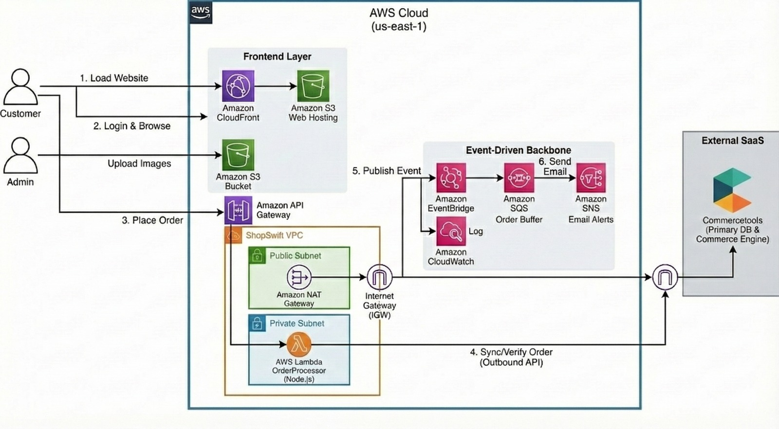
- Customers open the ShopSwift website, which loads quickly using Amazon CloudFront and Amazon S3 for static pages and images.
- CloudFront delivers content from nearby locations, reducing load time and improving user experience.
- Admin users upload product images directly to an Amazon S3 bucket, which stores them securely.
- When a customer places an order, the request goes through Amazon API Gateway, acting as the entry point to the backend.
- The backend logic runs inside a ShopSwift VPC, keeping the system secure and isolated.
- AWS Lambda processes orders inside a private subnet without managing servers.
- The order details are verified and synced with Commercetools, which handles products and orders.
- Once an order is placed, an event is published to Amazon EventBridge for further actions.
- Amazon SQS temporarily stores order messages, while Amazon SNS sends email notifications.
- Amazon CloudWatch logs and monitors the entire system to ensure smooth performance and quick issue detection.
Objective:
The objective of the ShopSwift project is to design and implement a fast, scalable, and reliable e-commerce platform using AWS cloud services and a microservices architecture. The system aims to improve website performance, handle high user traffic efficiently, enable real-time order processing, and provide personalized shopping experiences. By leveraging managed services such as Amazon S3, CloudFront, Lambda, and Commercetools, the platform ensures high availability, security, and easy scalability while reducing operational overhead.

